Money Matters: A Personal

Finance Management App

**1.Introduction**

**1.1** **Overview:**

A project built using the Android Compose UI toolkit. It demonstrate how to create

a simple travel app using the Compose libraries. It also features a personalized feed

of recommended accomodations based on the locations.

A

Money mat ters

Android Compose project is an application that helps

users to plan and organize their travel itineraries. The project can include several

features such as booking flights, reserving hotels, and finding local attractions and

events.

The project can be implemented using the Android Jetpack Compose framework,

which provides a modern and efficient way to build user interfaces. It can use

various libraries and APIs, such as Google Maps API for maps and location data

,

and a third-party API for flight and hotel booking. The app can also integrate

payment systems to enable secure transactions.

**1.2** **Purpose:**

The purpose of a money matters app is to help individuals manage their personal

finances effectively. Such an app can be designed to provide features like budget

tracking, expense tracking, bill reminders, and financial goal setting.

With the help of such an app, users can get a better understanding of their

spending habits, identify areas where they can save money, and make informed

financial decisions. The app can also help users to stay on track with their

financial goals, such as saving for a down payment on a house or paying off debt

.

Overall, a "Money Matters" app can help users take control of their finances,

improve their financial well-being, and make smarter financial decisions.

**2.Problem Definition & Design Thinking**

**2.1 Empathy map**

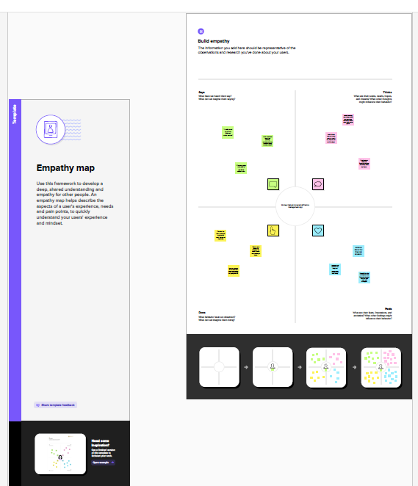

**2.2 Ideation & Brainstroming Map**

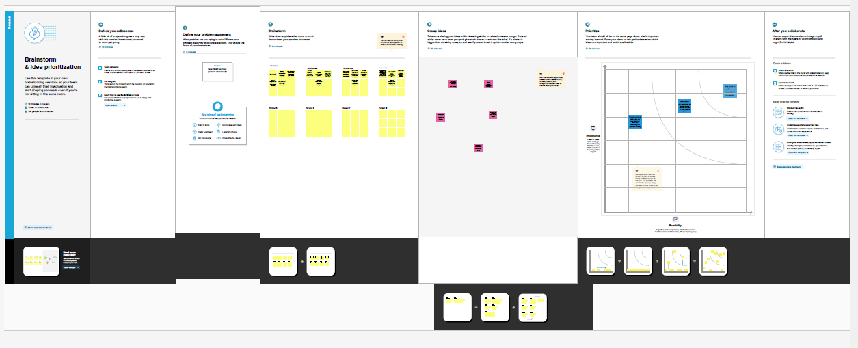

**3.Result**

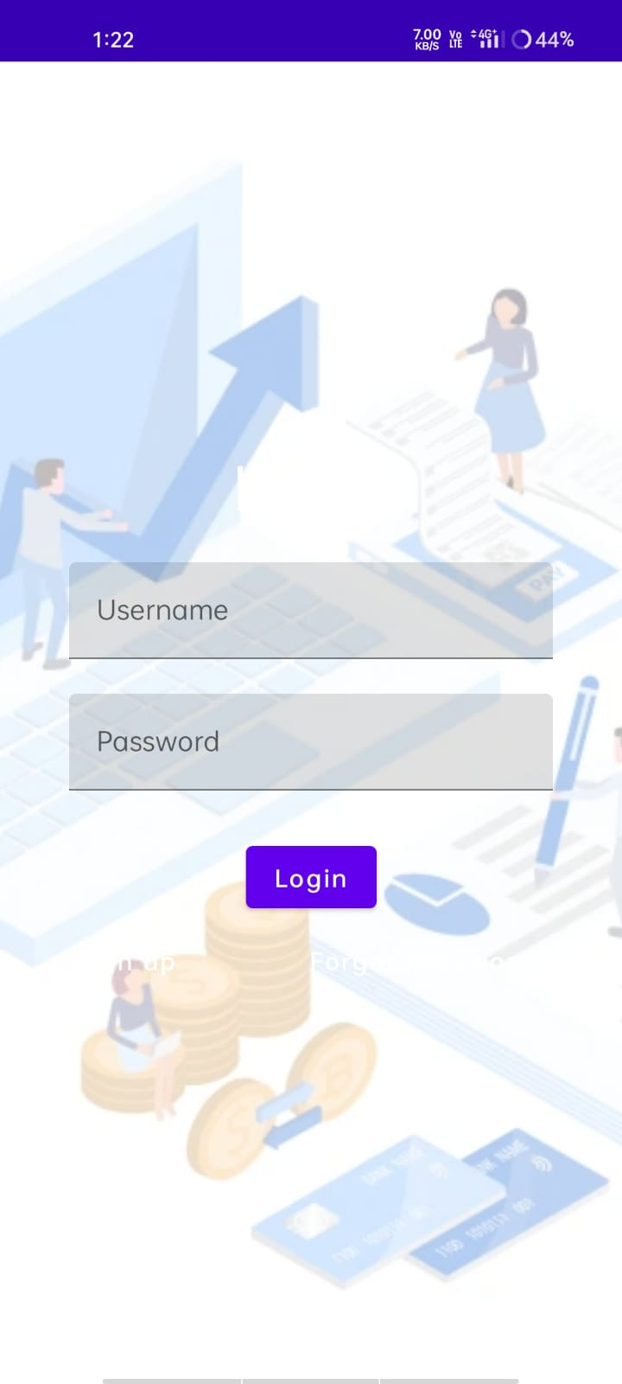

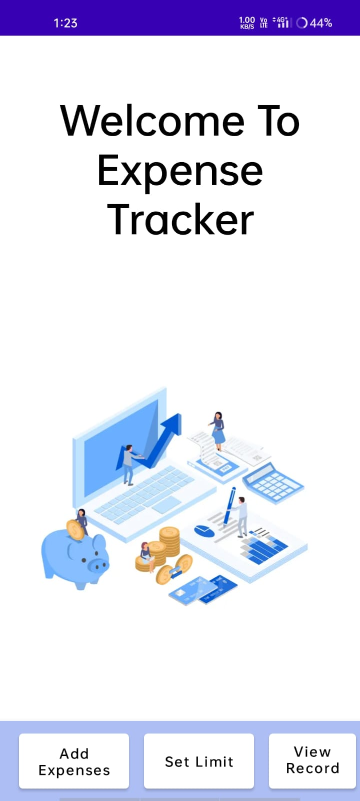

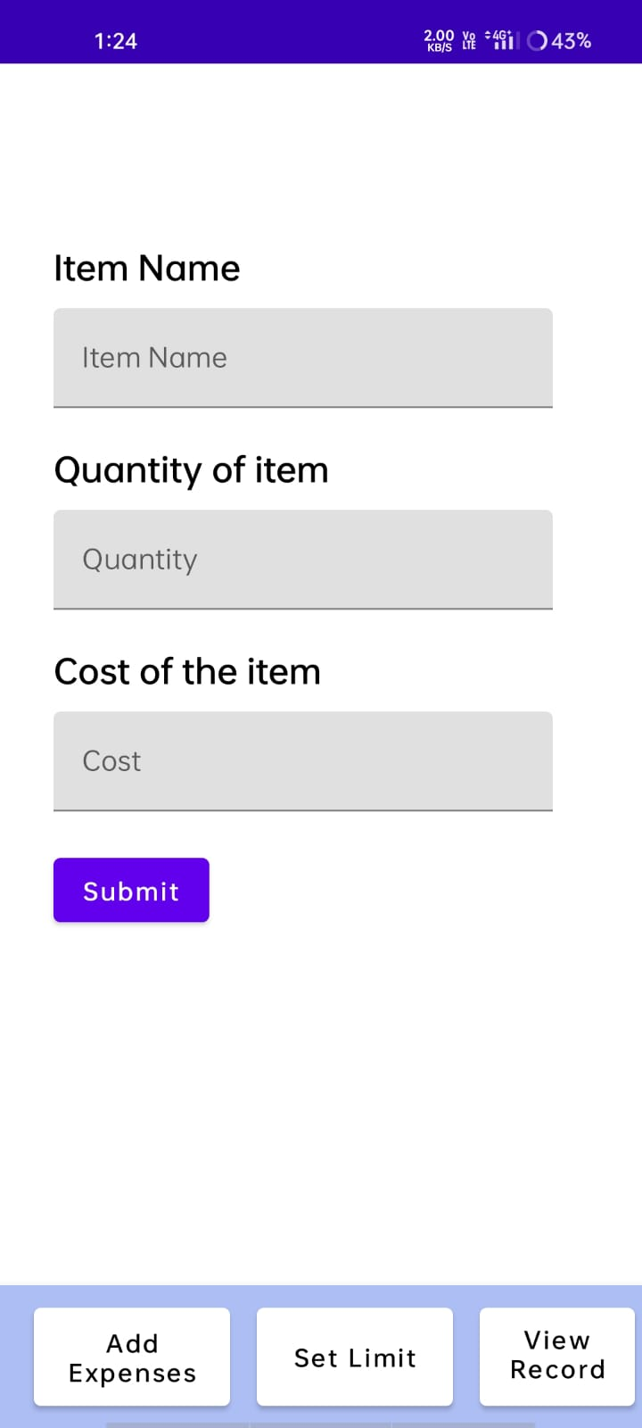

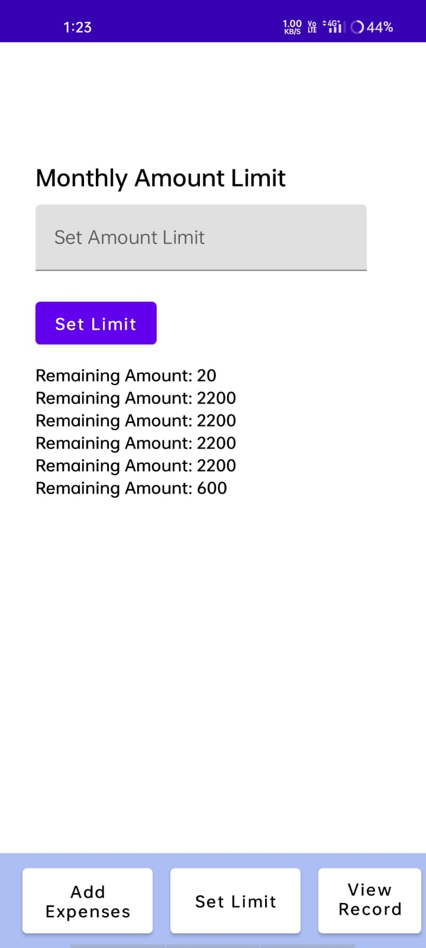

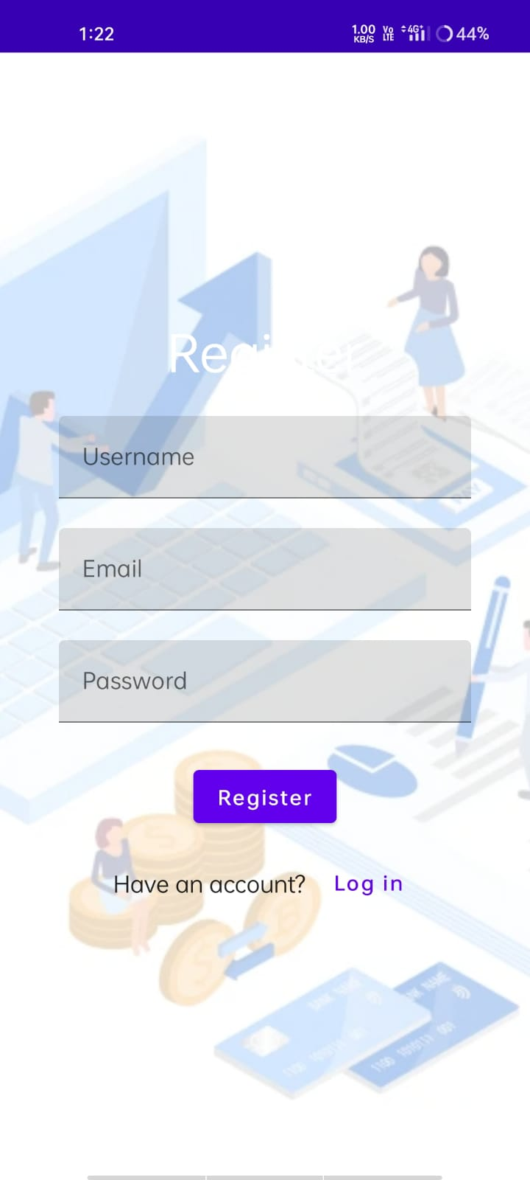

**4.Advantages & Disadvantages**

**Advantages**

• Improved Financial Awareness: A money management app can help you become

more aware of your financial situation by tracking your income and expenses. This

can help you identify areas where you may be overspending and where you can

make adjustments to your budget.

• Tracking expenses: Money matters app can allow you to track your expenses in real

time, helping you to stay on top of your spending and make more informed financial

decisions.

• Financial insights: Money matters app can provide you with insights and analytics

about your spending habits, helping you make informed decisions about your

money.

**Disadvantages**

• Technical issues: Money matters app can sometimes experience

technical glitches or outages, which can be frustrating and may cause

you to lose access to your financial information.

• Security concerns: Money matters app involves sharing sensitive

financial information, which can pose security risks if the app is not

properly secured. You should always make sure to use a reputable

app with strong security measures.

• Expense tracking limitations: Money matters app may not be able to

track all of your expenses if you use cash for some purchases or if you

have multiple bank accounts or credit cards.

**5.Application**

• A money matters application is a mobile app designed

to help users manage their finances. These apps can

offer a variety of features and tools to help users track

their income and expenses, set budgets, and monitor

their financial goals.

• Expense tracking: Users can input their income and expenses

into the app, which then tracks their spending over time. The

app may also automatically categorize expenses for easier

tracking.

• Budgeting tools: Users can set monthly or yearly budgets for

different expense categories, such as food, entertainment, or

transportation.lso

**6.Conclusion**

Personal financial management is done by every individual on some level. The key is to strike the right balance between income, expenses, savings, and investments. This balance will ensure that the personal financial planning and management of the individual are optimum

**7.Future Scope**

Prediction of future growth rates can be made using few algorithms in tableau. Accordingly many decisions can be made. Since there was a 5 day boot camp related to the challenge. I have restricted my project only to visualization considering the topics that have been taught.